1. Let’s create out first angular app using Angular CLI.
2. Let’s learn a bit more about **ng command** before getting started with creating an Angular App.
3. Ng help 🡸 Command to get help on angular client (Angular CLI) which gives all the command info.
4. 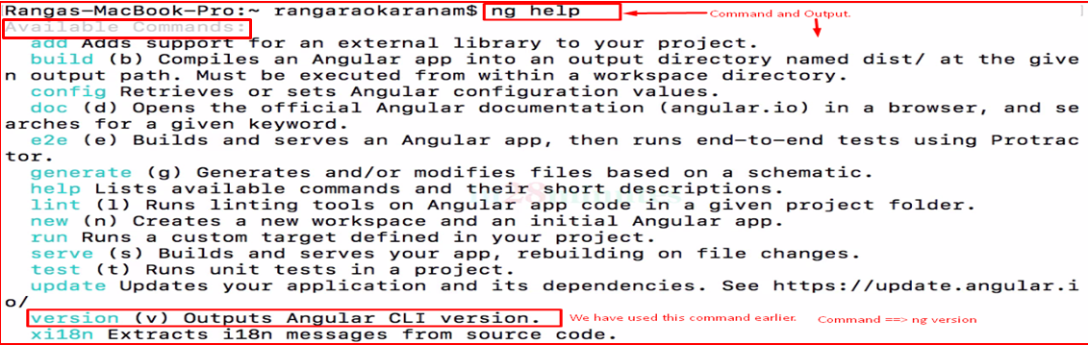
5. 
6. Let’s create angular project.
7. Select the folder where you want to create angular project in.
8. 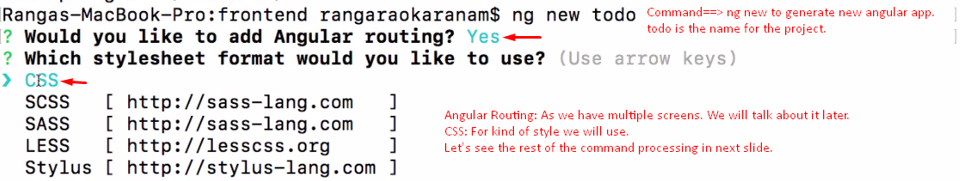
9. 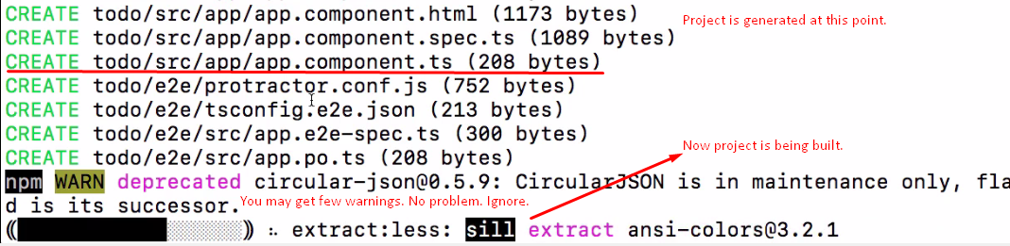
10. 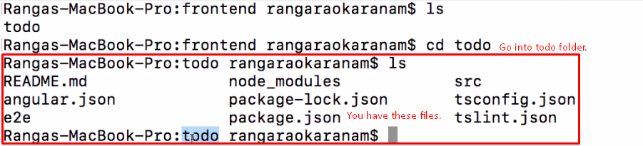
11. 